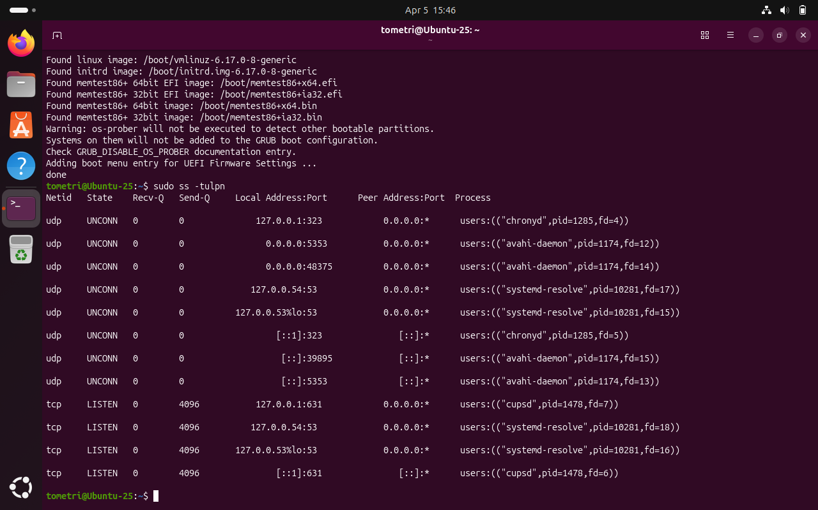
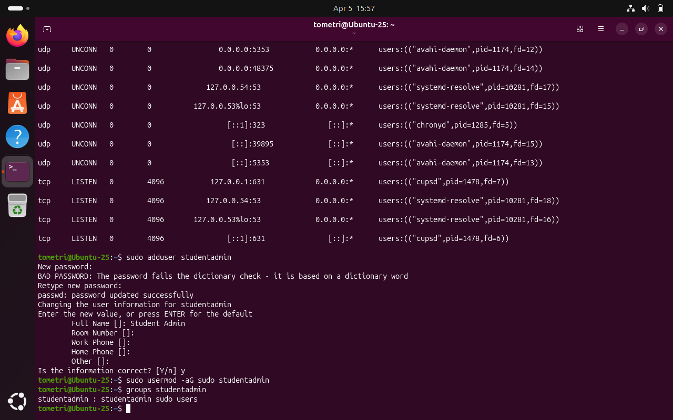
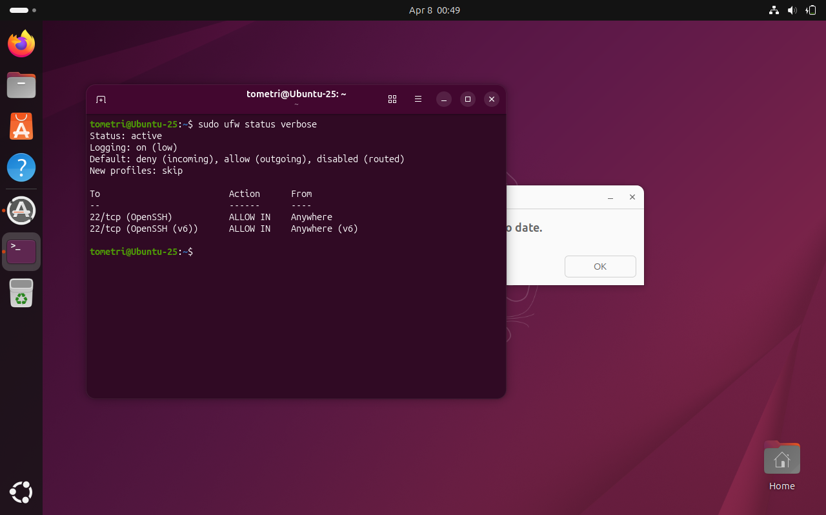
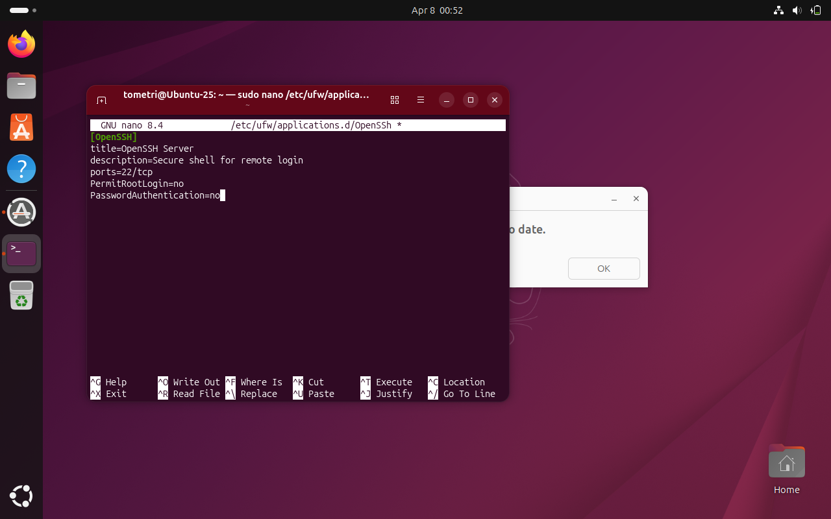
1.UFW will now block all incoming traffic unless explicitly allowed
2.Disabling root will require attackers to know both a valid username+password, and admins logging in with individual accounts and sudo usage leaves a trail to audit.
3.Passwords can be compromised, SSH key-based authentication is a good replacement.
4. The recommended modern standard is ed25519 as far as I can tell, so I would opt for that.

